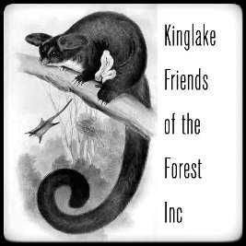

2021 Membership Application

Membership Contact Details

Name
Address
Email
Phone
DOB if under 18 years

Are you interested in becoming actively involved? Yes, I would like to become actively involved and have time to devote.

Kinglake Friends of the Forest do not charge a membership fee. Should you wish to make donation it would be gratefully accepted.

I would like to make donation to support the purpose of Kinglake Friends of the Forest Inc
 $5  $10  $20  $50  $100  Other …………

For direct transfer bank details are; Kinglake Friends of the Forest Inc BSB 633 000 Acc 170 560 155
At reference please state: donation

I, [insert name] ………………………

wish to apply to become a member of the Kinglake Friends of the Forest Inc and support of the Association as set out herewith. I agree to comply with the rules of the Association which are the Model Rules for an Incorporated Association as set out by Consumer Affairs Victoria and available on request.

Signed: ……………………………………………………………………………….… Date: …………………………………….

Our Purpose:
To provide a forum for people to learn about, discuss and advocate for the preservation of the native forests in Kinglake and the Central Highlands of Victoria

